
TOM MBOYA UNIVERSITY
KNOWLEDGE FOR SUSTAINABLE INNOVATION ENTERPRISE

2024/2025 ACADEMIC YEAR UNIVERSITY EXAMINATION

SECOND YEAR FIRST SEMESTER EXAMINATION FOR THE DEGREE OF MASTER OF CRIMINOLOGY WITH IT

MCR 802: ADVANCED SOCIAL STATISTICS

DATE: 17/12 2024 DURATION:3 HOURS
––––––––––––––––––––––––––––––––––––––––––––––––––––––––––––––––––

Read the instructions provided below carefully;
- Do NOT write on this question paper.
- This question paper contains SIX questions.
- Answer ANY FOUR questions of your choice.
- Marks allocated to each question is shown at the end of the question. (Each Question carries 15 Marks)
- Show ALL your workings in the answer booklet provided.

QUESTION ONE

- Although social statistics are widely used in analyses of social data, there are several limitations associated with them. Highlight some important limitations of social statistics. (4 Marks)
- A panel of two judges, A and B graded the acting performances by independently awarding marks to Kodiaga prisons inmates as follows.
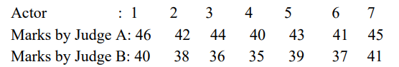
The performance of actor number 8 was awarded 37 marks by judge A while judge B forgot to award him any mark. If judge B has also awarded marks to actor number 8, what marks could be expected from him? (8 marks)
- Using a well labeled diagram, show the position of the mean, mode and the median in a negatively skewed distribution. (3 Marks)
QUESTION TWO
- The table below shows the age distribution of the police officers who participated in the police suicide and murder study. Calculate the median age of the participating officers and verify your answer graphically.
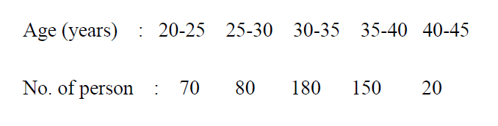 (7 marks)
- The mean lifetime of a sample of 100 light tubes produced by a company is found to be 1570 hours with standard deviation of 80 hours. Test the hypothesis that the mean lifetime of the tubes produced by the company is 1600 hrs. (8 Marks)

QUESTION THREE

- In a locality of 18000 families, a sample of 840 families was selected, of these 840 families, 206 families were found to have a monthly income of Ksh7000 or less. It is desired to estimate how many out of the 18000 families have a monthly income of Ksh3000 or less. Within what limits would you place your estimate. (7 marks)
- The following stem and leaf diagram gives the heights in cm of 39 of petty offenders arrested and remanded at Homabay Police station.
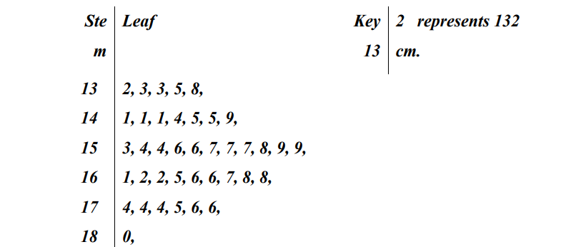
Required:
- State the lower quartile height. (1 mark)
- State the median height. (3marks)
- State the upper quartile height. (1 mark)
- Calculate the geometric mean. (3marks)
QUESTION FOUR

The table below shows the sales for Kasarani Police electronics shop established in the late 1998.
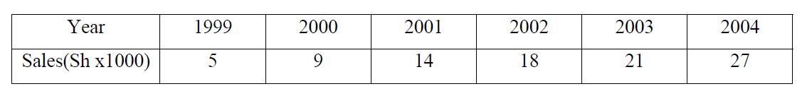 Draw a scatter graph to represent this data. (3marks)
- Find . (5 marks)
- Find the equation of the line of best fit using the linear regression formula. (4marks)
- Predict the sales for the year 2006, giving your answer to the nearest KSh. (3marks)

QUESTION FIVE

- Calculate the harmonic mean for the data given below: (6marks)
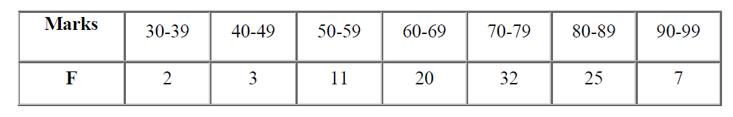

- Write shorts notes on the following;
- Linear and non-linear correlation. (3marks)
- Parametric and non-parametric tests. (3marks)
- Serial correlation and multi collinearity. (3marks)
QUESTION SIX
- The following is a payoff table for a particular venture.

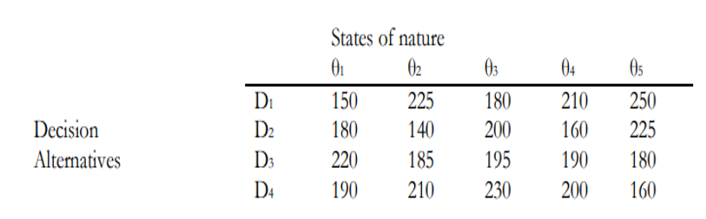
Required:

Determine the optimal decision using:

- Max-min criterion. (3 Marks)
- Max-max criterion. (3 Marks)
- Min-max regret criterion. (3 Marks
- Explain three decision making environments giving an example in each case
(6 marks)

