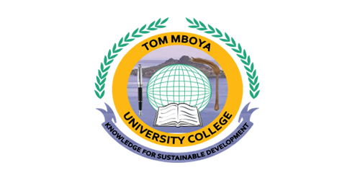
TOM MBOYA UNIVERSITY COLLEGE
(A CONSTITUENT COLLEGE OF MASENO UNIVERSITY)
UNIVERSITY COLLEGE EXAMINATIONS
2020/2021 ACADEMIC YEAR
FIRST SEMESTER EXAMINATION
FOR THE CERTIFICATE IN BUSINESS ADMINISTRATION

ACB 0100: ELEMENTS OF MANAGEMENT

DATE: 30/05/2021 TIME: 3 HOURS
INSTRUCTIONS TO CANDIDATES.
Answer question one (compulsory) and any other three questions
Question one carriers 25 marks and the rest 15 marks each

QUESTION ONE
a. Describe the nature and characteristics of management (10marks)
b. Explain briefly the functions of management (10marks)
c. List five roles of a manager according to Mintzberg’s managerial roles (5marks)
QUESTION TWO
a. Discuss the responsibility of a company director (10marks)
b. Explain various levels of management with an aid of diagram (5marks)

QUESTION THREE
a. Differentiate between management and administration (10marks)
b. Discuss types of organization culture (5marks)

QUESTION FOUR
a. Discuss the contributions of “Scientific Management” as propounded by Fredrick W. Taylor. (10marks)
b. Distinguish the difference between informal and formal communications (5 marks)
QUESTION FIVE
a. Describe the direction of communication flow in an organization (15 marks)

QUESTION SIX
a. Explain the objectives and importance of management (10 marks)
b. Explain what is meant by the terms doing things efficiently and doing things effectively (5 marks)

