

TOM MBOYA UNIVERSITY
KNOWLEDGE FOR SUSTAINABLE INNOVATION ENTERPRISE
UNIVERSITY EXAMINATIONS
2023/2024 ACADEMIC YEAR
DECEMBER 2023

THIRD YEAR FIRST SEMESTER EXAMINATIONS

SCH 305: FUNCTIONAL GROUP APPROACH IN ORGANIC SYNTHESIS

TIME: 3 HOURS
INSTRUCTIONS:
- Answer question ONE and ANY other TWO questions
- Question ONE carries 30 Marks, All other Questions carry 20 Marks each
- Electronic calculators may be used where necessary

EXAMINATION CHEATING IS A CRIME

QUESTION ONE (30 MARKS)
a) Briefly explain the meaning following the terms [6marks]
- Tautomer
- Organic synthesis
- Enolate
- Ylide
- Wittig reaction
- Stereoselective synthesis
b )Give the IUPAC names of the following compounds: [6 marks]
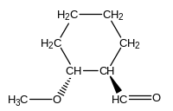(i) ii) 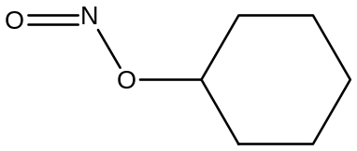 iii 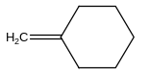
iv 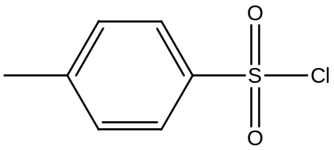 v 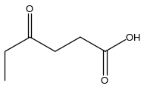vi 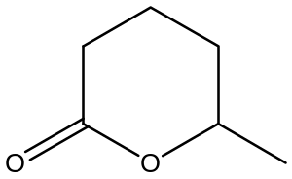
c) Identify the reagents and conditions required to obtain the products indicated in the reaction below: [3marks]

i) CH₃CH₂COOH + Reactant P 1. Reagent Q
2. Reagent R CH₃CH₂Br
3. Condition S

d) Give the structures of the following molecules: [5marks]

- N-Methyl-N-ethyl-3-hexanamine
- Methyl-3- chloropropanoate
- 3- Hydroxycyclopentane-1-carbaldehyde
- E-2-butene dioic acid
- 5-Hydroxypentanoic acid lactone

e) Explain the following observations:
i) Tertiary amines have lower boiling points than corresponding primary and secondary amines of similar molecular weight. [3marks]
ii) Solubility of alkanoic acids decreases with increase in molecular weight [2marks]
iii) Propanone is less reactive than propanal towards nucleophilic reactions [2marks]
f) Give the major products in the following reactions [3marks]
i) 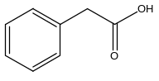 I₂, Pb(OAC)_{4,} HEAT A
ii) PhCHO + PhCH₂-PPh₃ PhLi B
iii) C₆H₅CH(CH₃)CH₂CONH₂ 1. LiAlH₄, Diethylether C
2. H₂O
g) Give the major products in the following reactions [2marks]

i) 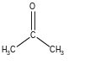 H⁺
ii) 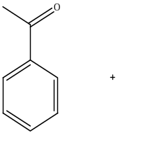 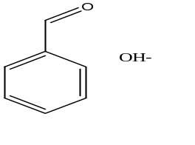
QUESTION TWO (20 MARKS)
a) The table below shows some physical properties of alcohols and carboxylic acids:
Molecule | Molecular weight | Boiling point/^{O}C
CH₃COOH | 60 | 118
CH₃CH₂CH₂OH | 60 | 97
Account for the difference in the boiling points between the two molecules [3marks]
b) The data below represents some physical property of acids. Use the information to account for the observed difference in acidic strength [5marks]
Acid | P^{Ka}
CH₃COOH | 4.7
CH₂(Cl)COOH | 2.6
CH(Cl₂)COOH | 1.26
C(Cl₃)COOH | 0.64

c) complete the following reactions: [5marks]
i)(CH₃)₂S=CH₂ + (CH₃)₂C=O A + B
ii) 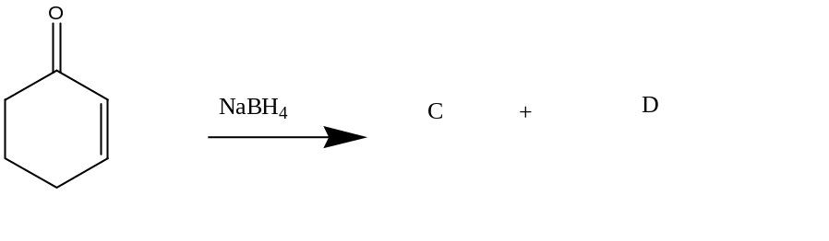
iii) 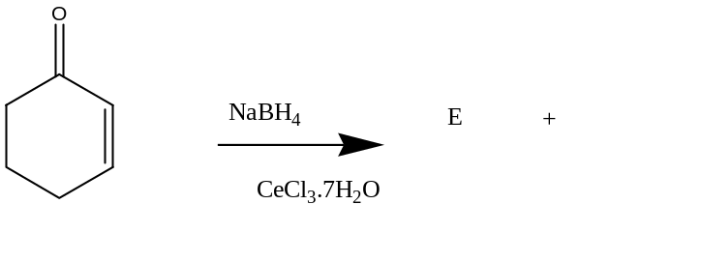

d) The reaction below represents Trans esterification. Write a reaction mechanism scheme to show how the products were obtained. [5marks] [6marks]
CH₃COOCH₂CH₃ + CH₃CH₂OH 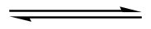CH₃COOCH₃ +CH₃CH₂OH
e) State two industrial applications of esters [2marks]

QUESTION THREE (20 MARKS)

a) Draw structures of the following molecules [2marks]
- 3-Methylethylnitrite
- Orthohydroxybenzoic acid

b) Outline a chemical test used to distinguish between aldehydes from ketone [2marks]
c) In Wittig reaction, explain why Ylides containing phosphorus are important [3marks]
d) ) Draw the structures of Ethyl formate, diethyl carbonate and diethyl oxalate and explain why they do not form Claisen product when treated with sodium ethanoate in thanol [4marks]
e)(i) Give all the products formed in the reaction below: [4marks]
CH₃CO₂Et + C₂H₅CO₂C₂H₅ 1. NaOH
2. H⁺

ii) How can the above reaction be made synthetically useful? [1mark]
c) Give the products in the reaction scheme below [4marks]

I) CH3CH₂CO₂C₂H₅ LDA A CH₃COCl B

II) C₆H₅CO₂CH₃ + CH₃CH₂CO₂CH₃ 1. NaH, C₆H₆ C + D 2. H₃O⁺

QUESTION FOUR (20 MARKS)

a) Soap is made by hydrolysis of fatty acids in presence of heat as illustrated in the reaction below:
CH₂OCO(CH₂)₁₄CH₃

CHOCO(CH₂)₁₆CH₃ + 3 NaOH PRODUCTS

CH₂OCO(CH₂)₇(CH₂)₉CH₃

- Give the systemic names and structures of all the products formed [4marks]
- Explain the mechanism of stain removal using soap. [6 marks]
- State one disadvantage of soap [ 1 mark]
b) What were the starting materials for the synthesis of the following molecules? Explain the feasibility of the reactions involving the synthons identified [9 marks]
- 
 