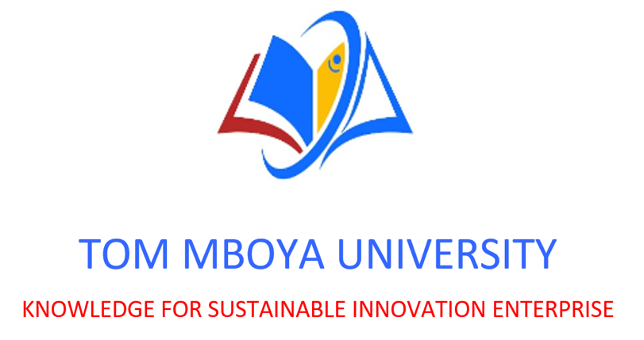

FACULTY OF BUSINESS AND ECONOMICS

2024/2025 ACADEMIC YEAR UNIVERSITY EXAMINATION

FIRST YEAR FIRST SEMESTER EXAMINATIONS FOR DIPLOMA IN BUSINESS ADMINISTRATION

ADB 0103: INFORMATION MANAGEMENT SYSTEMS.

DATE:6/08/2025 TIME:3 HOURS

INSTRUCTIONS:
Answer Question ONE (1) which is compulsory.
Choose ANY OTHER THREE (3) questions.
All questions carry the marks as indicated.

EXAMINATION CHEATING IS A CRIME
QUESTION ONE – Compulsory (25 Marks)
a) Define the term Information System and explain its key components. (5 marks)
b) Discuss five benefits an organization can derive from implementing a Management Information System (MIS). (10 marks)
c) Explain the stages in the System Development Life Cycle (SDLC). (10 marks)
QUESTION TWO (15 Marks)
a) Distinguish between data, information, and knowledge giving examples. (6 marks)
b) Explain the role of information systems in decision-making at the operational, tactical, and strategic levels. (9 marks)

QUESTION THREE (15 Marks)
- Describe three types of information systems used in organizations and give one example of each.
(9 marks)
b) Discuss three challenges organizations face when implementing new information systems. (6 marks)
QUESTION FOUR (15 Marks)
a) Explain how cloud computing is transforming modern business information systems. (6 marks)
b) Discuss the importance of data security in information systems and suggest three ways to enhance it.
(9 marks)
QUESTION FIVE (15 Marks)
a) Outline the ethical and legal issues surrounding the use of information systems in business. (7 marks)
b) Explain the term cyber security and describe four common cybersecurity threats to information systems. (8 marks)

QUESTION SIX (15 Marks)
- Discuss the role of enterprise resource planning (ERP) systems in streamlining business operations.
(7 marks)
b) Highlight four features of a good management information system. (8 marks)

